ATSC or QAM or ISDBT to IP gateway
H-8ISDBT-IP / H-8ATSC-IP / H-8DVBS-IP / H-8DVBT-IP / H-8QAM-IP
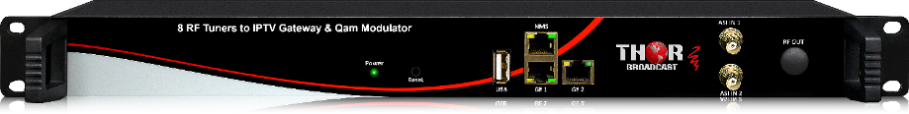
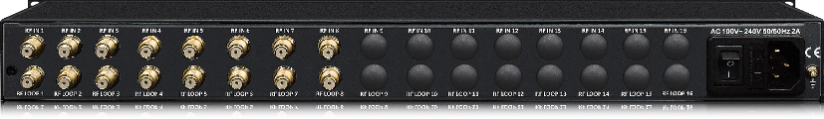

Preview

RF to IP Gateway

Broadcast FULL HD IPTV content from 8 TV frequencies that can be ATSC / QAM / DVBS-S2 / ISDB-T / DVB-T
AIR / Cable / SAT to LAN & WIFI IP Devices
EXAMPLE Model numbers can be ( H-8QAM-IP ---- H-8ATSC-IP ---- H-8DVBT-IP )

In today’s digital RF, each 6Mhz channel off air ATSC (8VSB) or CABLE TV QAM channels can contain many TV programs. For example 57Mhz is Ch #2, it can have programs 2.1, 2.3, and so on. This unit can convert all the TV programs inside the 8 frequencies and convert it directly to IPTV multicast or unicast, as well as, MUX'd ASI output. Unit features 2 ASI inputs as well, so it can be a multi ASI input to IP Gateway too.

- Converts 8 Antenna RF (off air) or cable Frequencies (channels) / ALL Received TV Services from each > TO > IPTV Streaming SPTS
- Output up to 45x spts RTP/UDP multicast streams you can receive on any computer, tablet, mobile, IP decoder

The 8 RF Tuner Input Multiplexer is the latest demodulation and multiplexing device for digital TV broadcasting head-end system with TS output through ASI and IP port. It can multiplex up to 8 channels tuned and 1 ASI input to one MPTS.This multiplexer has the functionality of supporting auto-generation of PSI/SI information, PID re-mapping, service filtering and PCR adjusting. This unit offers to be used in either MPTS format or SPTS allowing you to aggregate all your programs from the tuner, or parsing them through selection options in the program menu to customize the IP output. This units incredible integration and cost effective design make this device readily available is now widely used in the Next Generation of CATV Broadcasting system.
This is the simplest way to convert existing RF Channels to IP streams in a clear and direct manner, this unit does not encode, it is just a gateway so if the incoming cable QAM channels are MPEG2, then the output IP channels will be MPEG2, same goes with H264 as well. This is an easy to grab OTA or QAM frequencies and directly convert them to RTP/UDP Streams to an existing IPTV channel lineup

RF to IP Gateway + RF Transmodulator

Take existing Broadcast RF channels and convert them to IP streams PLUS convert them to RF channels
This unit can take existing ATSC channels and convert them to IP streams and QAM RF channels simultaneously
(RF input = IP + RF output)
RF Inputs can be ATSC / QAM / DVBS-S2 / ISDB-T / DVB-T
RF Outputs can be ATSC / QAM / ISDB-T / DVB-T
EXAMPLE Model numbers can be:
(H-8ATSC-IP-8ATSC ---- H-8ATSC-IP-8QAM ---- H-8QAM-IP-8ATSC ---- H-8QAM-IP-8QAM --- H-8DVBS-IP-QAM)

This gateway and transmodulator is a unique device that can easily convert existing RF streams, up to 8 frequencies and convert to IP and RF channels. This will allow you to add any RF to existing RF channel bank as well as create IP streams for easy access via LAN. For consideration you can convert DVB-T to IP and QAM, or you can convert ATSC to IP and QAM, or also use it as a translator so you can take 8 QAM frequencies and convert to IP and 8 QAM (different frequencies, if you like to rearrange your channel lineup). The vast array of options make this an ideal headend piece to quickly and efficiently become more dynamic, add free OTA channels to a QAM headend, or simply create a RF to IP gateway with existing RF programs. This is the exact same unit that is mentioned above with the added benefit of transmodulation, we can essentially mix and match any RF to any RF with a couple exceptions. Please contact your local dealer or Thor directly for more information.

Features
- 8 Tuner (DVB-S2/DVB-T)
- 8 Tuner (ATSC)
- 8 Tuner (QAM)
- 8 Tuner (ISDB-T)
- QAM-256/64 & ATSC (8VSB) formats supported
- IP TS output
- MPTS over UDP, RTP/RTSP output as mirror of ASI output (RJ45)
- SPTS optional as well
- 2 ASI Inputs means it can be used as a dual ASI to IP Gateway as well
- Integrated demodulating and multiplexing functions

- Select which channels to stream out via SPTS
- Multiplex one program to all outputs
- Closed Captions supported
- Full IP control and Network Management through browser
- IPTV Output Unicast or Multicast IGMP UDP
- Low Latency available 10-20ms
- AC3, MPEG2 Audio
- MPEG2 Video or MPEG4 H.264
- Perfect Full HD Video Quality - No Loss
- 2 Year Warranty

Input | PN: H-8ATSC-IP  PN: H-8QAM-IP  PN: H-8DVBS-IP  PN: H-DVB-T-IP  PN: H-ISDB-T-IP | 8 x ATSC Antenna  8 x Cable QAM  8 x Satellite S2  8 x DVB-T Antenna  8 x ISDB-T Antenna
Supported Resolutions | All HD and SD
Video Codecs | MPEG-2 HD 1.5-19.5 Mbps  H.264 HD 0.8-19.5 Mbps
Audio Codecs | MPEG-1 Layer II  MPEG-2 AAC  MPEG-4 AAC AC3 Dolby
Audio Sample Rate | 48 kHz
Audio Bit Rates | 64 kbps, 96 kbps, 128 kbps, 192 kbps, 256 kbps, 320 kbps
Modulation Standard | ATSC, DVB-C, DVB-S2 (model dependent)
RF Frequency Range | 30-960 MHz for QAM and ATSC, 850-2100Mhz for L-band
Input RF Power Level | 5-35 dBmV
IPTV Output | MPTS over UDP, RTP/RTPS out as mirror of ASI output (RJ45)
Power Input | 100-240 VAC Auto-Switching ~ 20 W
Dimensions | 19 x 9 x 3 Inches
Weight | 6 Pounds
Operating Temperature | 32-110 F
*All Specifications Subject to Change Without Notice

